EX.NO: 4 | Build and analyze MDP models.
DATE:

AIM:
To implement Value Iteration to find the optimal policy and state values in a stochastic Grid World using a Markov Decision Process (MDP).

PROCEDURE:
1.Create the 3×4 Grid World environment.
2.Define actions and stochastic transition probabilities.
3.Assign rewards for goal, pit, and other states.
4.Initialize all state values to zero.
5.Apply the Value Iteration algorithm using the Bellman equation.
6.Repeat updates until convergence is achieved.
7.Determine the optimal policy from the computed state values.

CODE:
import numpy as np
import matplotlib.pyplot as plt
GAMMA = 0.9
INTENDED_PROB = 0.8
class StochasticGridMDP:
def __init__(self, intended_prob=INTENDED_PROB):
self.rows = 3
self.cols = 4
self.states = [(r, c) for r in range(self.rows) for c in range(self.cols)]
self.actions = [0, 1, 2, 3]
self.action_deltas = {
0: (-1, 0),
1: (0, 1),
2: (1, 0),
3: (0, -1)
}
self.goal_state = (0, 3)
self.pit_state = (1, 3)
self.wall_state = (1, 1)
self.intended_prob = intended_prob
self.slip_prob = (1.0 - intended_prob) / 2.0
def is_terminal(self, state):
return state in [self.goal_state, self.pit_state]
def _get_next_pos(self, state, action):
r, c = state
dr, dc = self.action_deltas[action]
next_r = r + dr
next_c = c + dc
if (
next_r < 0 or next_r >= self.rows or
next_c < 0 or next_c >= self.cols or
(next_r, next_c) == self.wall_state
):
return state
return (next_r, next_c)
def get_transitions(self, state, action):
if self.is_terminal(state):
return [(1.0, state, 0.0)]
transitions = {}
intended_next = self._get_next_pos(state, action)
transitions[intended_next] = transitions.get(intended_next, 0) + self.intended_prob
slip_left_action = (action - 1) % 4
slip_left_next = self._get_next_pos(state, slip_left_action)
transitions[slip_left_next] = transitions.get(slip_left_next, 0) + self.slip_prob
slip_right_action = (action + 1) % 4
slip_right_next = self._get_next_pos(state, slip_right_action)
transitions[slip_right_next] = transitions.get(slip_right_next, 0) + self.slip_prob
result = []
for next_s, prob in transitions.items():
if next_s == self.goal_state:
reward = 1.0
elif next_s == self.pit_state:
reward = -1.0
else:
reward = -0.04
result.append((prob, next_s, reward))
return result
def value_iteration(mdp, gamma=GAMMA, theta=1e-4):
V = {s: 0.0 for s in mdp.states}
policy = {s: 0 for s in mdp.states}
while True:
delta = 0
new_V = V.copy()
for s in mdp.states:
if s == mdp.wall_state or mdp.is_terminal(s):
continue
action_values = []
for a in mdp.actions:
expected_value = sum(
prob * (reward + gamma * V[next_s])
for prob, next_s, reward in mdp.get_transitions(s, a)
)
action_values.append(expected_value)
best_value = max(action_values)
new_V[s] = best_value
policy[s] = np.argmax(action_values)
delta = max(delta, abs(best_value - V[s]))
V = new_V
if delta < theta:
break
V[mdp.goal_state] = 1.0
V[mdp.pit_state] = -1.0
return V, policy
def plot_mdp_analysis(mdp, V, policy):
fig, ax = plt.subplots(figsize=(8, 6))
v_grid = np.zeros((mdp.rows, mdp.cols))
for r in range(mdp.rows):
for c in range(mdp.cols):
v_grid[r, c] = V[(r, c)
v_grid[mdp.wall_state[0], mdp.wall_state[1]] = np.nan
cax = ax.matshow(v_grid, cmap='RdYlGn', vmin=-1, vmax=1)
fig.colorbar(cax, label="State Value")
arrows = {0: '↑', 1: '→', 2: '↓', 3: '←'}
for r in range(mdp.rows):
for c in range(mdp.cols):
s = (r, c)
if s == mdp.wall_state:
ax.text(c, r, "WALL", va='center', ha='center', color='white', weight='bold')
elif s == mdp.goal_state:
ax.text(c, r, f"{V[s]:.2f}\nGOAL", va='center', ha='center', weight='bold')
elif s == mdp.pit_state:
ax.text(c, r, f"{V[s]:.2f}\nPIT", va='center', ha='center', weight='bold')
else:
ax.text(c, r - 0.2, f"{V[s]:.2f}", va='center', ha='center')
best_act = policy[s]
ax.text(c, r + 0.2, arrows[best_act], va='center', ha='center', fontsize=18, weight='bold')

ax.set_xticks(np.arange(-0.5, mdp.cols, 1), minor=True)
ax.set_yticks(np.arange(-0.5, mdp.rows, 1), minor=True)
ax.grid(which="minor", color="black", linestyle='-', linewidth=2)
ax.set_xticks([])
ax.set_yticks([])
plt.title("Optimal State Values and Policy using Value Iteration")
plt.tight_layout()
plt.show()
if __name__ == "__main__":
mdp = StochasticGridMDP()
V, policy = value_iteration(mdp)
plot_mdp_analysis(mdp, V, policy)

OUTPUT:

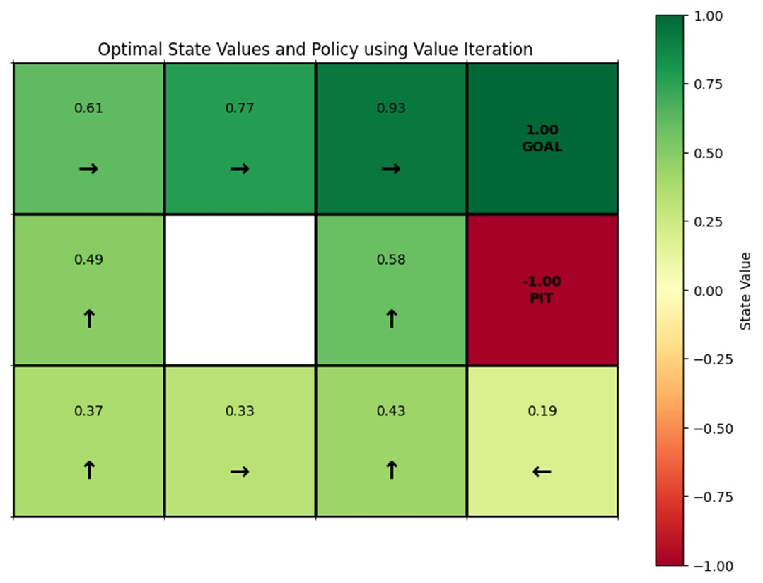

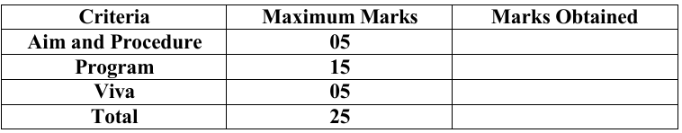

RESULT:
The Value Iteration algorithm successfully converged and computed the optimal state values and policy for the stochastic 3×4 Grid World.

